AS51
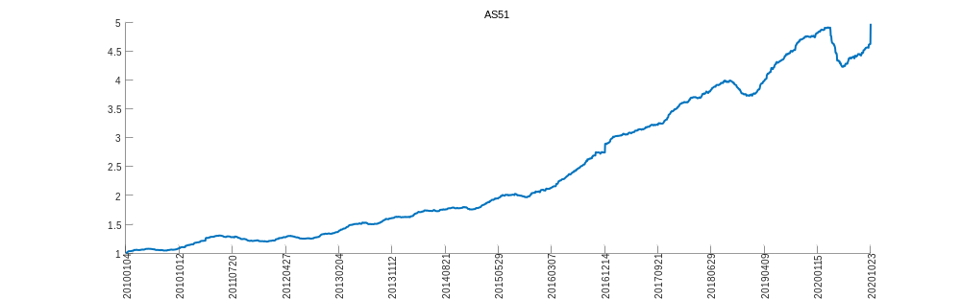
hscei
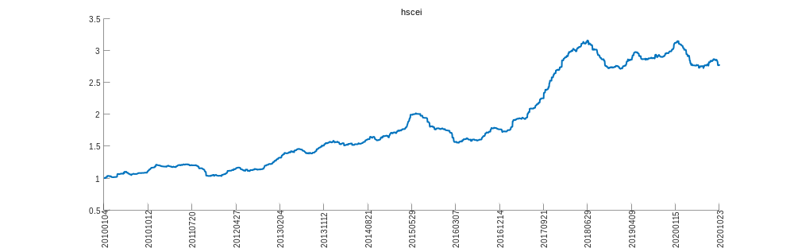
hsi
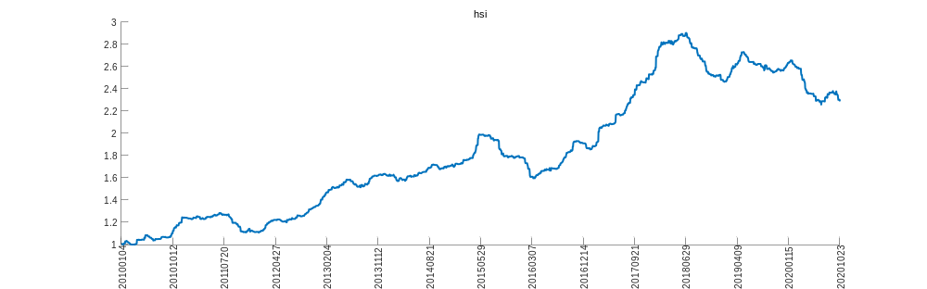
msci
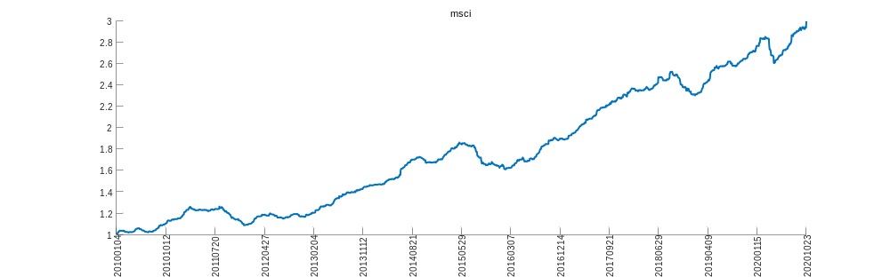
nky
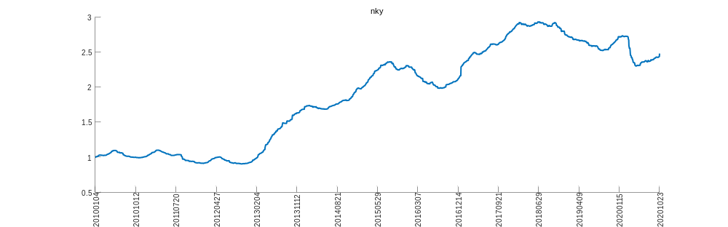
topix
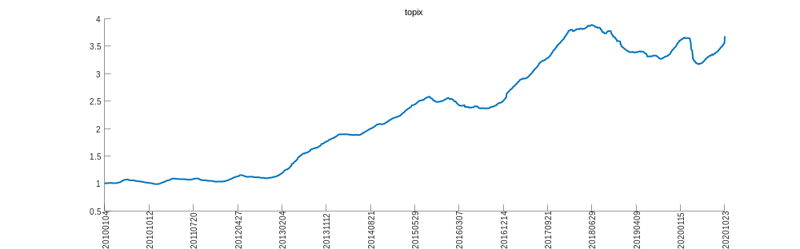
Nifty
